Agentic AI
The main foundation of agentic ai – finding out and decomposing the task into steps
Agents might find it harder if the steps are not all know.
Evaluation of agentic ai:
LLM as a judge

Design patterns:-
1)Reflection – reflect and improve, boost it with extrenal reflection.
Zero-sjot prompting- generation without any examples relys only on the pretrained. Adding reflection always boots the performance of the LLM
2)

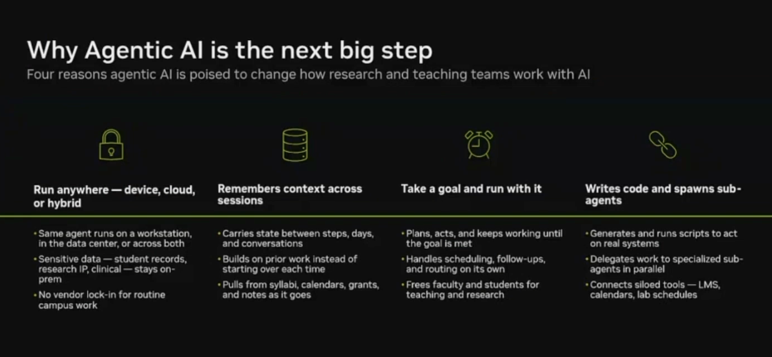

Codebase Intelligence Assistant using RAG
So the golden rule of RAG chunking is:
Each chunk should contain one idea, one function, or one logical unit
Chunking strategy:-
Decision | Why
Chunk by function | One idea per chunk = high relevance scores
Tag with class name | Preserves context for the Synthesizer
Tag with file + line | Critic can cite sources accurately

Basic python backend structure –
fake_repo/
├── main.py # entry point
├── auth.py # JWT authentication
├── db.py # database connections
├── server.py # API endpoints
└── error.py # error handling
For each function in a python file – metadata of each function would be the class its from
Eg-chunk 1: "def generate_jwt..." → metadata: {class: "AuthenticationService", file: "auth.py", line: 8}
chunk 2: "def validate_jwt..." → metadata: {class: "AuthenticationService", file: "auth.py", line: 14}
chunk 3: "def refresh_token..." → metadata: {class: "AuthenticationService", file: "auth.py", line: 21}

to pasrse each function in a python file we make use of ast – the python abstract tree parser.

So the rule is:
Skip __init__ — it's configuration, not logic
This is actually a common RAG optimization called noise filtering — removing chunks that would never be a useful answer.
Rule | Reason
Chunk by function | One idea = high relevance scores
Tag with class + file + line | Preserves context
Skip __init__ | Noise filtering
There is a chunker.py function that implements this chunking strategy.

ChromaDB- vector database:
Vectored b- mainly used for rag applications and recommendation systems.
raw code → embedding model → vector → stored in ChromaDB
"how does JWT validation work" → embedding → KNN search → top-k similar vectors
Uses consine similarity.

Academic Planner Agent
Goal- plan my week , agent figures out the remaining
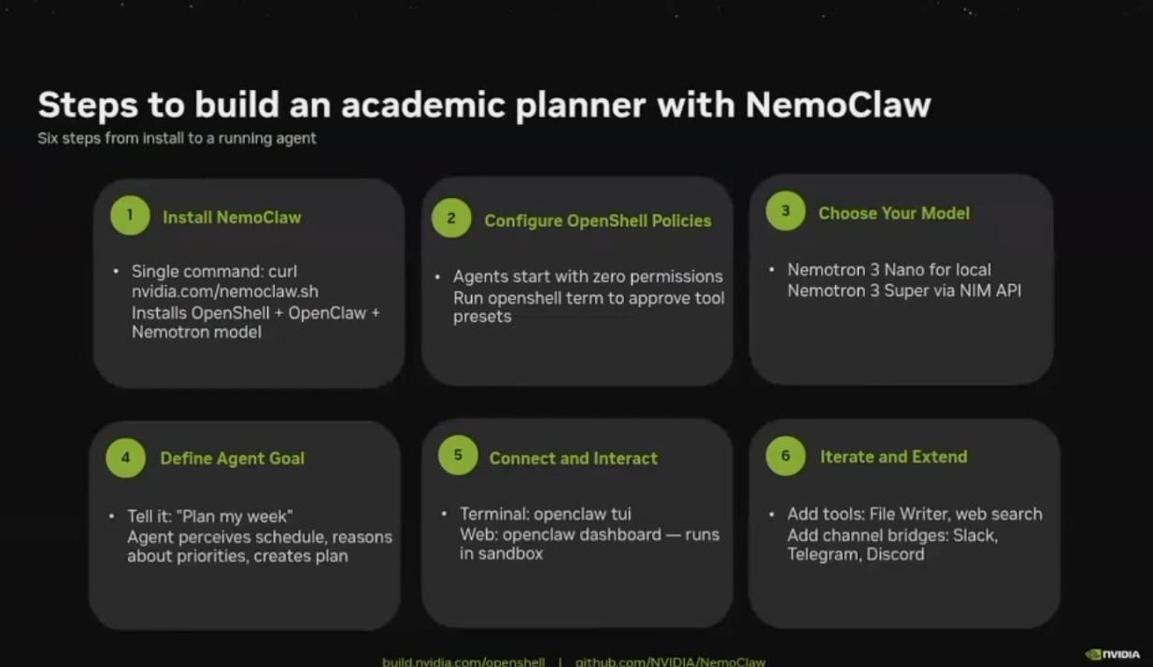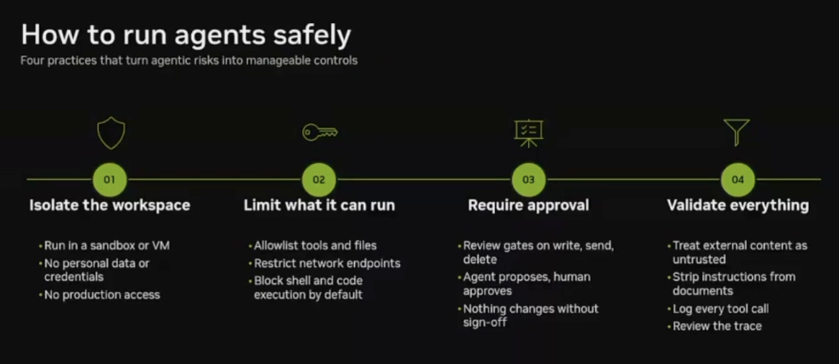
DGXspar- agent computer to build and host claws and autonomous agents safely.
Agents use 15 times more tokens than the normal chat agents – research by anthropic ai

